ENVIRONMENT SETUP

CREATE A FLASK PROJECT

|  |  |
| --- | --- |
| TEAM ID | PNT2022TMID43156 |
| PPROJECT NAME | NUTRITION ASSISTANT APPLICATION |

CODE:

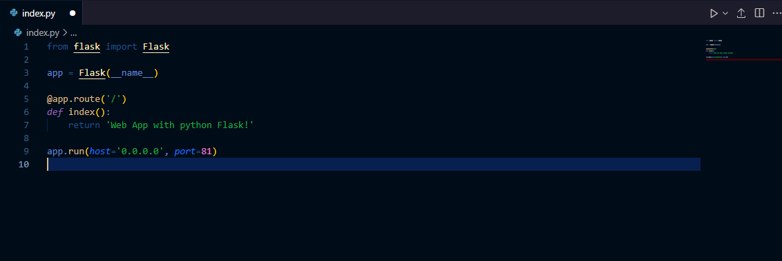

TERMINAL:

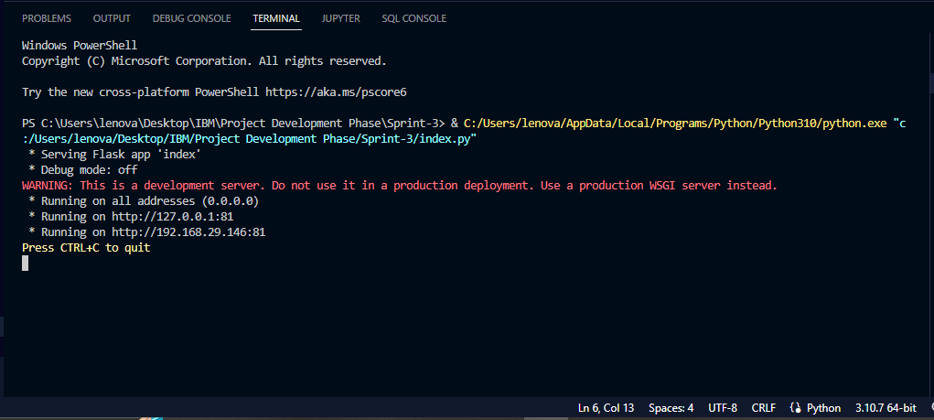

OUTPUT:

